

Department of Computer Science & Engineering

*Course ID – BUS 402*

**Self-Assessment for** **Selecting the Right Career Path**

**Submitted To:**

Ms. Parveen Sultana Huda

**Submitted By:**

Rashik Rahman

17201012

Section:A

**1st test: Personality test :**

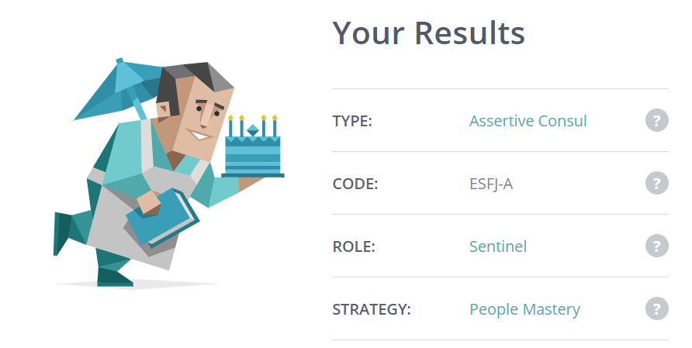

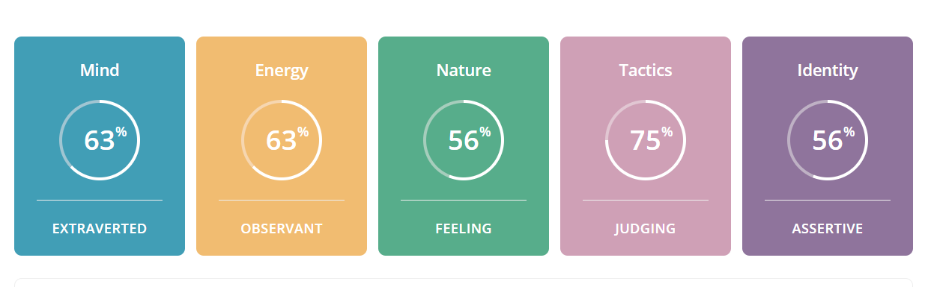

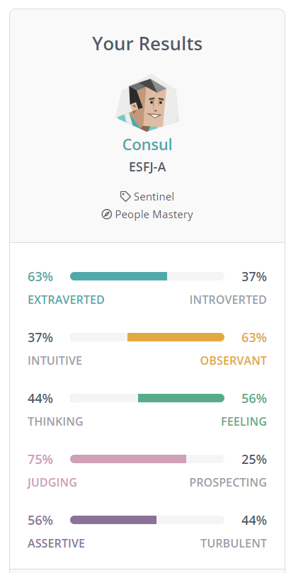

**Introduction:**

A **Consul (ESFJ)** is a person with the [Extraverted](https://www.16personalities.com/articles/mind-introverted-vs-extraverted), [Observant](https://www.16personalities.com/articles/energy-intuitive-vs-observant), [Feeling](https://www.16personalities.com/articles/nature-thinking-vs-feeling), and [Judging](https://www.16personalities.com/articles/tactics-judging-vs-prospecting) personality traits. They are attentive and people-focused, and they enjoy taking part in their social community. Their achievements are guided by decisive values, and they willingly offer guidance to others.People who share the Consul personality type are, for lack of a better word, popular – which makes sense, given that it is also a very common personality type, making up twelve percent of the population. In high school, Consuls are the cheerleaders and the quarterbacks, setting the tone, taking the spotlight and leading their teams forward to victory and fame. Later in life, Consuls continue to enjoy supporting their friends and loved ones, organizing social gatherings and doing their best to make sure everyone is happy.Discussing scientific theories or debating European politics isn’t likely to capture Consuls’ interest for too long. Consuls are more concerned with fashion and their appearance, their social status and the standings of other people. Practical matters and gossip are their bread and butter, but Consuls do their best to use their powers for good.Consuls are altruists, and they take seriously their responsibility to help and to do the right thing. Unlike their Diplomat relatives however, people with the Consul personality type will base their moral compass on established traditions and laws, upholding authority and rules, rather than drawing their morality from philosophy or mysticism. It’s important for Consuls to remember though, that people come from many backgrounds and perspectives, and what may seem right to them isn’t always an absolute truth.Consuls love to be of service, enjoying any role that allows them to participate in a meaningful way, so long as they know that they are valued and appreciated. This is especially apparent at home, and Consuls make loyal and devoted partners and parents. Consul personalities respect hierarchy, and do their best to position themselves with some authority, at home and at work, which allows them to keep things clear, stable and organized for everyone.Supportive and outgoing, Consuls can always be spotted at a party – they’re the ones finding time to chat and laugh with everyone! But their devotion goes further than just breezing through because they have to. Consuls truly enjoy hearing about their friends’ relationships and activities, remembering little details and always standing ready to talk things out with warmth and sensitivity. If things aren’t going right, or there’s tension in the room, Consuls pick up on it and to try to restore harmony and stability to the group.Being pretty conflict-averse, Consuls spend a lot of their energy establishing social order, and prefer plans and organized events to open-ended activities or spontaneous get-togethers. People with this personality type put a lot of effort into the activities they’ve arranged, and it’s easy for Consuls’ feelings to be hurt if their ideas are rejected, or if people just aren’t interested. Again, it’s important for Consuls to remember that everyone is coming from a different place, and that disinterest isn’t a comment about them or the activity they’ve organized – it’s just not their thing.Coming to terms with their sensitivity is Consuls’ biggest challenge – people are going to disagree and they’re going to criticize, and while it hurts, it’s just a part of life. The best thing for Consuls to do is to do what they do best: be a role model, take care of what they have the power to take care of, and enjoy that so many people do appreciate the efforts they make.

**Defender Strengths:**

* Strong Practical Skills – Consuls are excellent managers of day-to-day tasks and routine maintenance, enjoying making sure that those who are close to them are well cared for.
* Strong Sense of Duty – People with the Consul personality type have a strong sense of responsibility and strive to meet their obligations, though this may sometimes be more from a sense of social expectations than intrinsic drive.
* Very Loyal – Valuing stability and security very highly, Consuls are eager to preserve the status quo, which makes them extremely loyal and trustworthy partners and employees. Consuls are true pillars of any groups they belong to – whether it is their family or a community club, people with this personality type can always be relied upon.
* Sensitive and Warm – Helping to ensure stability, Consul personalities seek harmony and care deeply about other people’s feelings, being careful not to offend or hurt anybody. Consuls are strong team players, and win-win situations are the stuff smiles are made of.
* Good at Connecting with Others – These qualities come together to make Consuls social, comfortable and well-liked. Consul personalities have a strong need to “belong”, and have no problem with small talk or following social cues in order to help them take an active role in their communities.

**Defender Weaknesses:**

* Worried about Their Social Status – These Strengths are related to a chief Weakness: Consuls’ preoccupation with social status and influence, which affects many decisions they make, potentially limiting their creativity and open-mindedness.
* Inflexible – Consuls place a lot of importance on what is socially acceptable, and can be very cautious, even critical of anything unconventional or outside the mainstream. People with this personality type may also sometimes push their own beliefs too hard in an effort to establish them as mainstream.
* Reluctant to Innovate or Improvise – Just as they can be critical of others’ “unusual” behavior, Consuls may also be unwilling to step out of their own comfort zones, usually for fear of being (or just appearing) different.
* Vulnerable to Criticism – It can be especially challenging to change these tendencies because Consuls are so conflict-averse. Consul personalities can become very defensive and hurt if someone, especially a person close to them, criticizes their habits, beliefs or traditions.
* Often Too Needy – Consuls need to hear and see a great deal of appreciation. If their efforts go unnoticed, people with the Consul personality type may start fishing for compliments, in an attempt to get reassurance of how much they are valued.
* Too Selfless – The other side of this is that Consuls sometimes try to establish their value with doting attention, something that can quickly overwhelm those who don’t need it, making it ultimately unwelcome. Furthermore, Consuls often neglect their own needs in the process.

**Career Paths:**

Because Consuls’ traits are so strongly expressed, leading with practical sense and social vigor, the careers they find most satisfying usually revolve around making the best use of these qualities. Consuls are well-organized, enjoying bringing order and structure to their workplaces, and often work best in environments with clear, predictable hierarchies and tasks. Monotony and routine work are not a challenge for the Consul personality type, as they are happy to do what needs to be done.

**Cooperation, not Conflict**

Careers as administrators are a natural fit, allowing Consuls to organize not just an environment, but the people in it. Their practical skills combine well with their dependability, making Consul personalities surprisingly good accountants – though they often prefer to be personal accountants, helping people and interacting with them directly, instead of corporate accountants crunching numbers in some back room.

Purely analytical careers are often too dull for Consuls though – they need human interaction and emotional feedback to be truly satisfied in their line of work. Good listeners and enthusiastic team members, people with the Consul personality type are excellent providers of medical care and social work. Teaching is another great option, as Consuls are comfortable with authority, but are supportive and friendly enough to keep that authority from feeling overbearing.

*Consuls’ best careers all have the additional benefit of providing them with perhaps their most important requirement: to feel appreciated and know they’ve helped someone.*

Being as altruistic as they are, Consuls find it hard to be satisfied unless they know they’ve done something valuable for another person. This is often the driving force behind Consuls’ careers and career advancement, and makes religious work and counseling particularly rewarding.

Whatever they choose to do, Consul personalities’ comfort with busy social situations and practical knowledge and skills come together to create people who are not just able to be productive and helpful, but people who genuinely enjoy it.

**Workplace Habits:**

When it comes to the workplace, Consuls have clear tendencies that show through regardless of their position. People with the Consul personality type thrive on social order and harmony, and use their warmth and social intelligence to make sure that each person knows their responsibilities and is able to get done what needs to get done. Consuls are comfortable, even dependent on clear hierarchies and roles, and whether subordinates, colleagues or managers, Consul personalities expect authority to be respected and backed up by rules and standards.

**Consul Subordinates**

With clearly defined responsibilities and a sense of purpose, Consuls are patient, efficient, hard-working people who respect the authority of their managers. While Consuls may struggle with too much freedom and improvisation, they thrive in workplaces with structure, safety and guidelines. Routine tasks are not a problem for Consuls, and their dedication and loyalty earn them the respect of their managers.

**Consul Colleagues**

Teamwork is a concept that Consuls have no trouble putting into practice. Often seeking friends at work, people with this personality type are almost always willing to lend a hand when and where it’s needed. Excellent networkers, Consuls always seem to “know just the guy” to bring a project together on time. On the other hand, Consuls often need to work on a team – being stuck alone chipping away at paperwork for days on end just leaves them tired and unfulfilled.

Consuls take pride in these qualities, which has the side effect of making them particularly sensitive when they come under criticism. When their suggestions and help are turned down, Consul personalities can take it personally. Already somewhat vulnerable to stress, rejections like these can be pretty demoralizing, and Consuls may need their coworkers to make an effort to express their appreciation from time to time.

**Consul Managers**

Consuls enjoy the responsibility that comes with organizing social situations, and the enjoyment they feel in managing other people translates well into management positions. As team leaders, Consuls find ways to make everyone feel involved, uniting people and smoothing relations in order to get things done.

At the same time, Consuls have a strong respect for traditional power structures, and if after all their efforts convincing their subordinates to work together someone ends up challenging their authority, they can stress out, lose their temper, and just generally react badly. People with the Consul personality type are sensitive about their status and dislike conflict, and prefer situations where everyone knows their role. So long as expectations are clearly outlined, Consuls are effective and enjoyable managers.

**Conclusion**

Few personality types are as practical and caring as Consuls. Known for their social and administrative skills, Consuls are good at creating and maintaining a secure, stable and friendly environment for themselves and their loved ones. Consuls’ dedication is invaluable in many areas, including their own personal growth.

Yet Consuls can be easily tripped up in areas where their kindness and practical approach are more of a liability than an asset. Whether it is finding (or keeping) a partner, learning to relax or improvise, reaching dazzling heights on the career ladder, or managing their workload, Consuls need to put in a conscious effort to develop their weaker traits and additional skills.

What you have read so far is just an introduction into the complex concept that is the Consul personality type. You may have muttered to yourself, “wow, this is so accurate it’s a little creepy” or “finally, someone understands me!” You may have even asked “how do they know more about me than the people I’m closest to?”

This is not a trick. You felt understood because you were. We’ve studied how Consuls think and what they need to reach their full potential. And no, we did not spy on you – many of the challenges you’ve faced and will face in the future have been overcome by other Consuls. You simply need to learn how they succeeded.

But in order to do that, you need to have a plan, a personal roadmap. The best car in the world will not take you to the right place if you do not know where you want to go. We have told you how Consuls tend to behave in certain circumstances and what their key strengths and weaknesses are. Now we need to go much deeper into your personality type and answer “why?”, “how?” and “what if?”

This knowledge is only the beginning of a lifelong journey. Are you ready to learn why Consuls act in the way they do? What motivates and inspires you? What you are afraid of and what you secretly dream about? How you can unlock your true, exceptional potential?

Our premium profiles provide a roadmap towards a happier, more successful, and more versatile YOU! They are not for everyone though – you need to be willing and able to challenge yourself, to go beyond the obvious, to imagine and follow your own path instead of just going with the flow. If you want to take the reins into your own hands, we are here to help you.

**2nd test:** **Career Tests :**

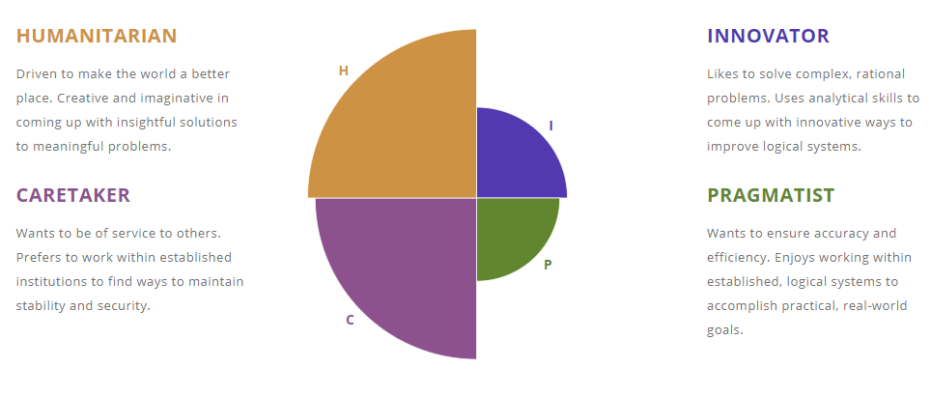

**Career Personality Profiler**

**HUMANITARIAN**

Driven to make the world a better place. Creative and imaginative in coming up with insightful solutions to meaningful problems.

#### INNOVATOR

Likes to solve complex, rational problems. Uses analytical skills to come up with innovative ways to improve logical systems.

#### CARETAKER

Wants to be of service to others. Prefers to work within established institutions to find ways to maintain stability and security.

#### PRAGMATIST

Wants to ensure accuracy and efficiency. Enjoys working within established, logical systems to accomplish practical, real-world goals.

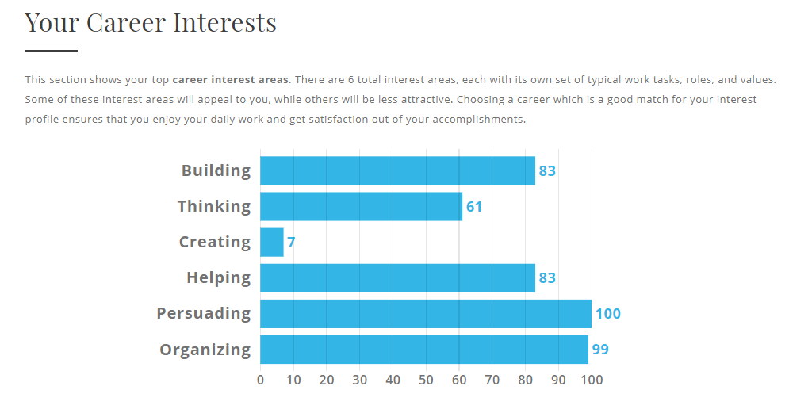

**3rd test: O*Net Interest Profiler :**

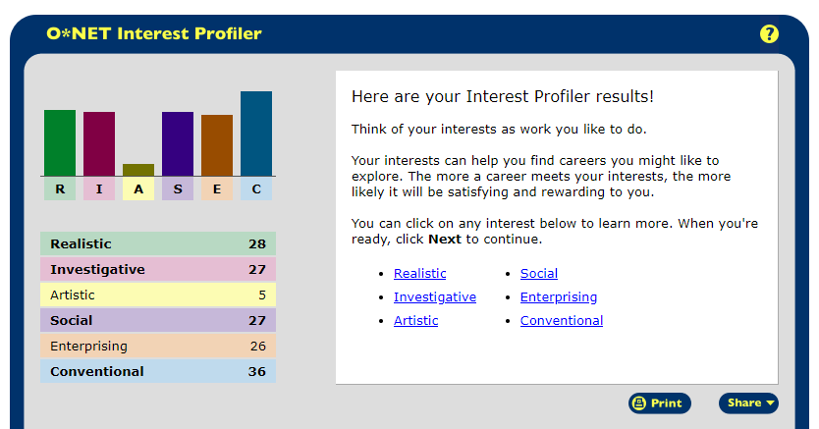

Job Zone:   
Medium Preparation Needed

Examples

